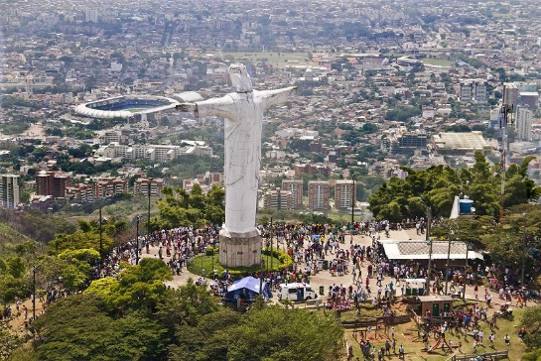
Talking about …
The city where you live!!!
Cali
Search information about Cali and answer the following questions:
- (Check the questions and Copy the links to answer them and work in class!!!)

- Where do you live?
- What is the full name of this city?
- Why is it called Santiago de Cali?
- Santiago was contributed by the conquerors in honor to : _____________________________ one of the _________________ of Jesus, and Patron of Spain.
- Cali comes from an _______________________ that means “ fabric made of fibers, a man who has no gratitude, a light object, and severity.” The term Cali was used by _________________ groups to mention the conquerors
- Where is it located in Colombia?
- Cali is located ______________________________________________ of Colombia (to the east – to the west , in the South , in the North , in the northeast - in the Southeast )
- Paste a picture to show its location in Colombia
- When was Cali founded? When is its birthday? How old is it?
- Name the limits of Cali
- Cali limits to the west with________________________
- To the East with __________________________________
- To the North with _________________________________
- To the South with _________________________________
- Paste or draw a map of Cali, and locate its limits.
- Who were the original inhabitants of Cali?
- Who was its founder? Where was SB from?
- Paste a picture of its founder.
- When was its independence?
- Its Independence was on ___________________________________
- Why Cali is the main urban and economic Center in the Southwest of the country? Because…
- Talk about its economy
- Name three main factories in Cali
- What is its main public transport?
- Paste a picture
- Is there a bus Central Station in Cali?
- Paste a picture.
- What is the name of its airport? Where is it located?
- Paste a picture
- Who is its mayor? Talk about him –Who is he? Where is he from?
- Paste a picture of him
- How is Cali called around the world? Name three nicknames
- Why is it called “Sport Capital of Colombia”?
- Why Cali is known as “The Salsa Capital”?
- Paste picture about it-
- Name 10 interesting places to visit in Cali.
- Paste pictures
- Choose three of them and write a short information about them
- What is the name of its stadium?
- Paste a picture
- Name five sport places in Cali
- Paste pictures
- Name five important rivers of Cali.
- Paste pictures
- Think
How can you help to protect the rivers of Cali?
- Name 2 ways

- Name five universities in Cali
- Name five museums in Cali-
- Paste pictures.
- Name three important cultural celebrations in Cali. When are they celebrated?
- Paste pictures
- Name five typical food from Cali
- Paste pictures
- Draw its flag or paste a picture about it.
- Do you like your city? Why?
- I like Cali because __________________________
- I don’t like Cali Because __________________

- COMPLETE THE FOLLOWING INFORMATION ABOUT CALI.

- Cali is the capital of __________________________ department
- Cali is the _______________________ (first, second, third) largest city in the country.
- In Cali, there are ______________________________ people approximately
- People from Cali are called _______________________
- “Caleños” are ____________________________and _________________ (opposite of unfriendly - sad)
- “Caleños” _________________________________________ salsa very well
- Its average temperature is _______________________
- Is Cali a hot city? __________________________________
- Is Cali a cold city? ________________________________
- Is Cali a cool city? _________________________________
- In Cali ___________________(there are - there aren’t ) many mountains around it.
- In Cali ___________________ (there are - there aren’t) street festivals, nice restaurants, and other activities to enjoy.
- What can you do in Cali on weekends?

