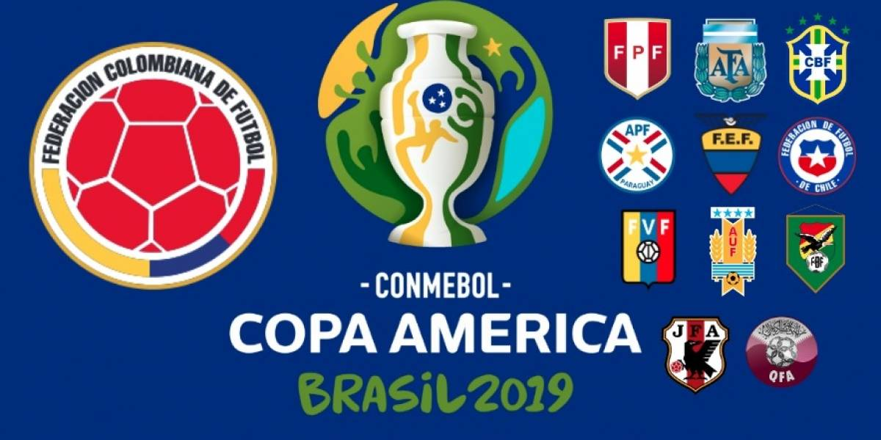

Make a presentation about the country you chose.

Answer the following questions

- What is the name of the country?
- Where is it located? Explain in a map, showing its borders.
- What is the nationality of people from this country?
- What is the population of this country?
- What is its capital?
- What is the official currency in this country?
- What is its official language?
- Name five interesting places to visit and talk about them. (use pictures)
- Name three typical food from this country and explain their ingredients. (use pictures)
- Choose two people from this country and talk about them.

- Name.
- Last name.
- Age,
- When was he/she born?
- Family
- Physical description
- Likes and dislikes (He/she likes……. He/she doesn’t like….)
- Daily routine

- It’s important to Use pictures to your presentation!!

