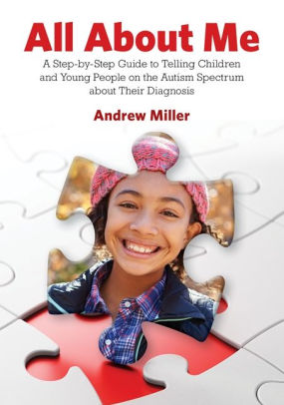
Make a magazine about yourself https://es.calameo.com/
ALL ABOUT ME!!!!!
Use the pages you need (minimum 6)

- Introduce yourself (name, last name, country, grade, school, etc.)
- Talk about your likes and your dislikes (color, sport, food, subject, music, favorite character, etc. )
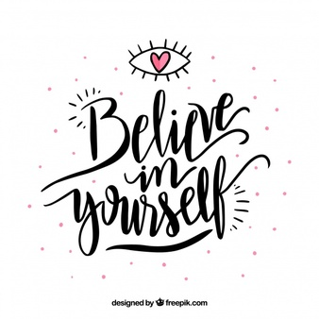
- Talk about your routine.
- Who do you live with?
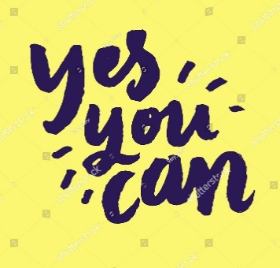
- Talk about your best friend.
- Talk about your neighborhood.
- Talk about your dream house.
- Talk about your city.
- Write a motivational phrase!

Finish your magazine answering this question:
- What would you like to be, when you finish your school?
Example:
When I finish my school, I would like to be a pop star.

It´s important to paste pictures.
Use the text worked and checked in class.

Work hard and Good luck!!!

This work must be presented on 26th April !!

