BROCHURE:
INTERESTING PLACES TO VISIT IN CALI
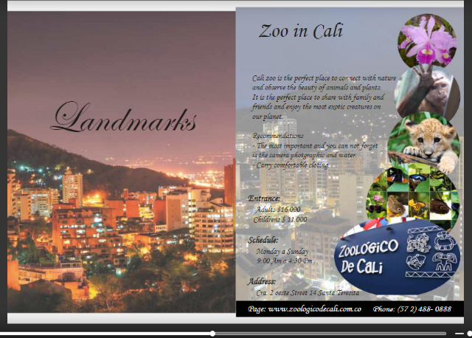
MAKE A BROCHURE OF THE PLACE THAT YOU CHOSE.
TAKE INTO ACCOUNT THE FOLLOWING ASPECTS:
- Name of the place
- Pictures of this place
- History of this place – When was it founded?
- Where is it located?
- How can you get there?
- What things are there in this place?
- What can you do in this place?

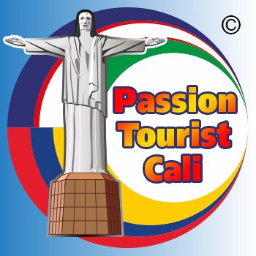
- Make a tourist ad to invite people to visit this place.
(Look the example from book page 35)

