My Dream House
4th Worksheet
Talk about “Your dream house”

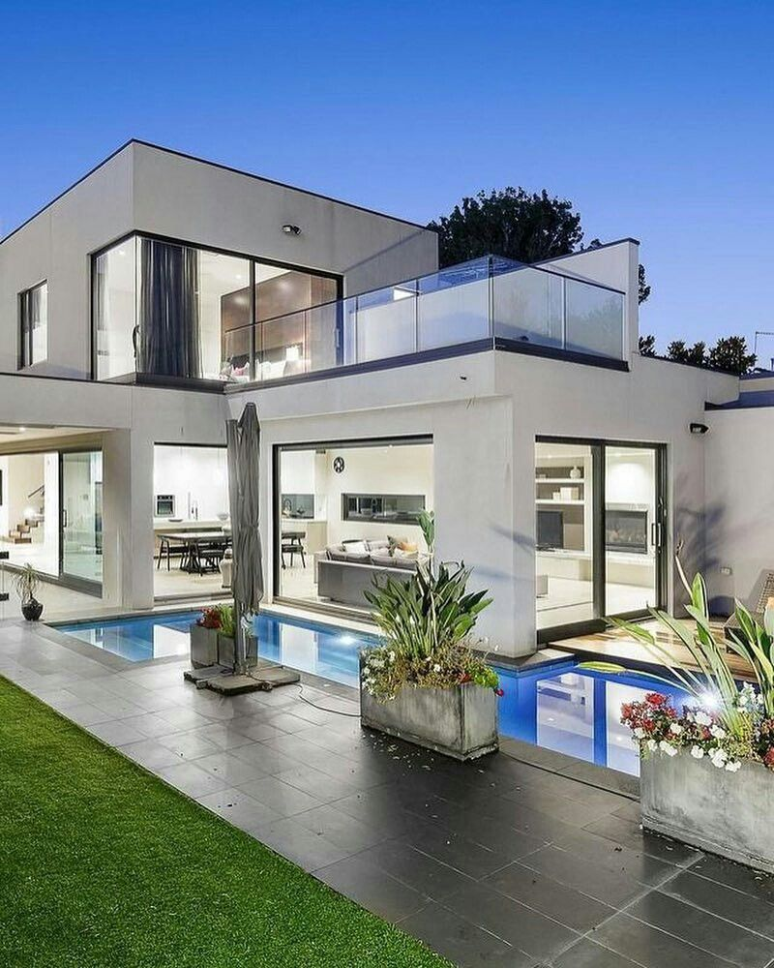
Write a text about “Your dream house”. Paste pictures about it.
- What is your dream house (house, villa, flat, castle)?
- Where is your dream house (place: country or city ?
- How large is your dream house (small, large…)?
- How many floors are there in your dream house?
- How many rooms are there in your dream house?
- How many bedrooms, living rooms, dining rooms, bathrooms… are there in your dream house?
- Are there any animals in your dream house?
- Is there any swimming pool in your dream house?
- Is there any garden in your dream house?

Use the presentations and the questions as a basis.
- Use there is /there isn’t, there are/there aren’t, has…
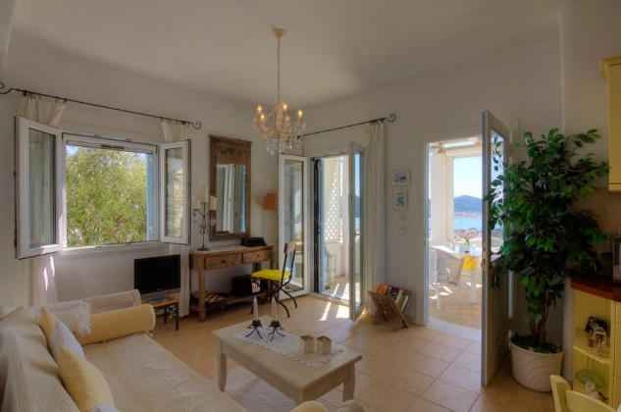
- Use the prepositions: under / on, next to, between, near/ far, in, in front of, behind, around, etc., to write your text.
